Ideation Phase
Define the Problem Statements

Date | 20 February 2026
Team ID | LTVIP2026TMIDS41306
Project Name | Plugging into the Future: An Exploration of Electricity Consumption Patterns Using Tableau
Maximum Marks | 2 Marks

Plugging into the Future: An Exploration of Electricity Consumption Patterns Using Tableau – Problem Statement
Electricity consumption data is generated in large volumes across different regions and sectors, but traditional reports and raw datasets make it difficult to analyze usage patterns, peak demand periods, and seasonal variations. The absence of interactive and visual analytical tools limits effective interpretation of this data, creating challenges for utility providers and policymakers in making informed decisions. Therefore, there is a need for a visualization-driven solution that converts complex electricity consumption data into clear, interactive dashboards to support efficient energy analysis and planning.
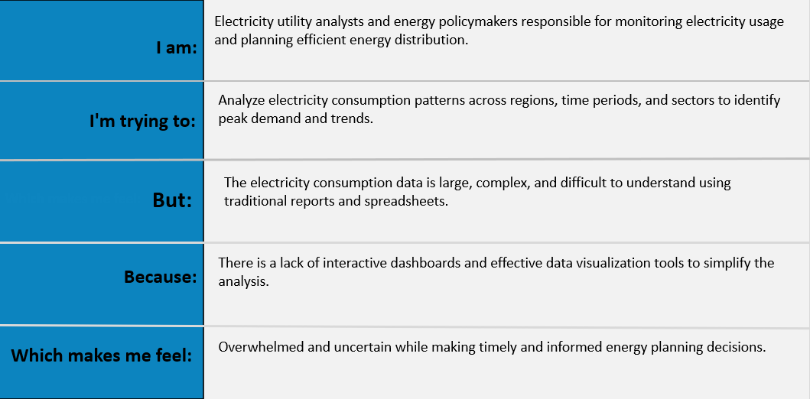
Reference: https://miro.com/templates/customer-problem-statement/
Example:
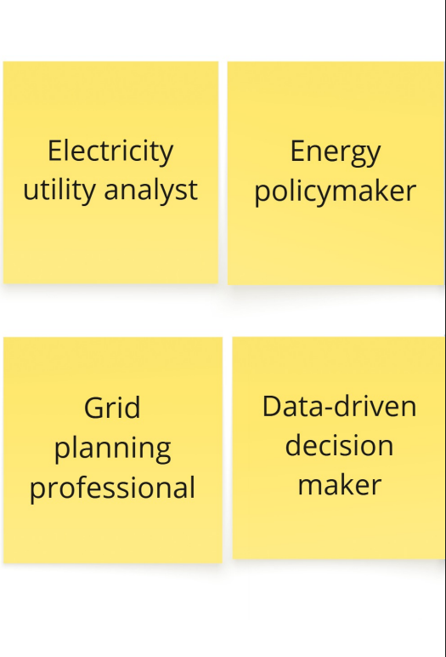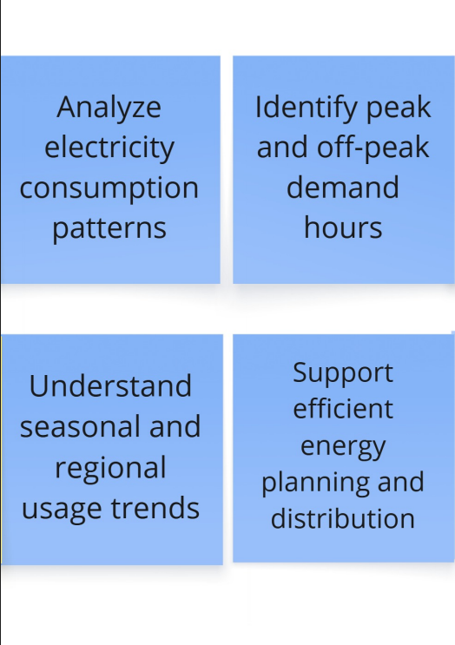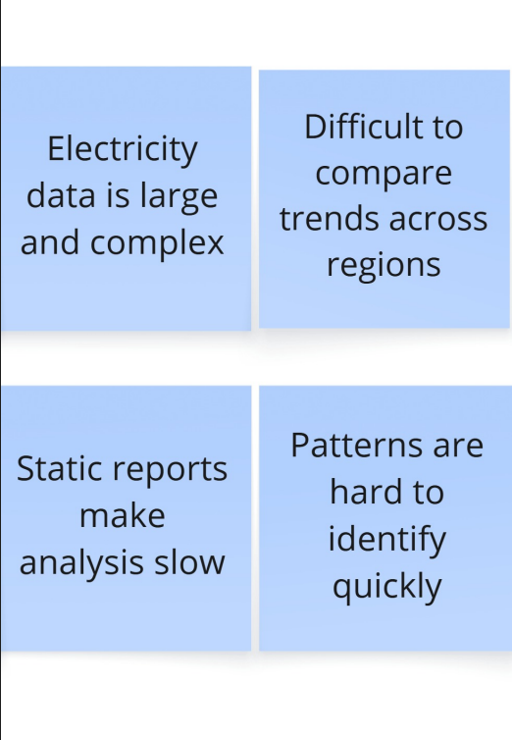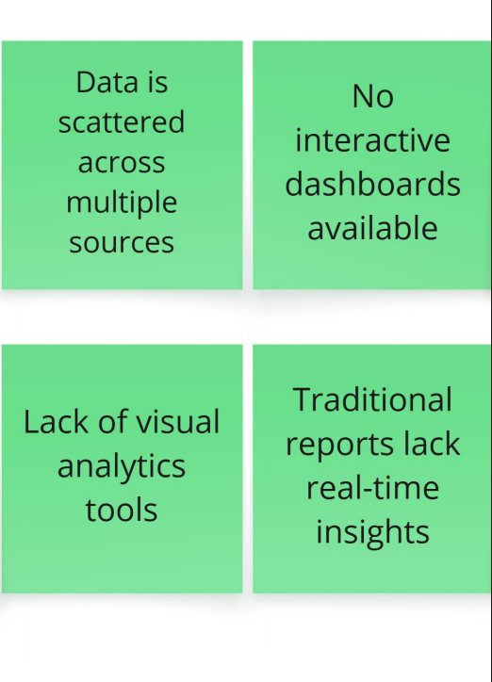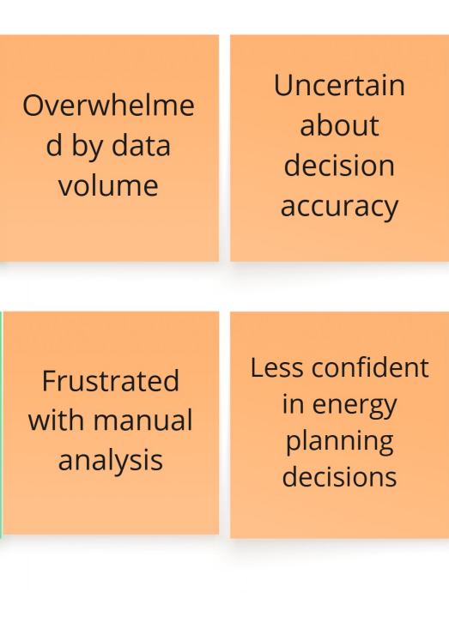

Problem Statement (PS) | I am (Customer) | I’m trying to | But | Because | Which makes me feel
PS-1 | an electricity utility analyst | identify peak electricity demand patterns | data is scattered and complex | there’s no unified visual dashboard | unsure about demand planning
PS-2 | an energy policymaker | track regional electricity consumption trends | I can’t compare trends easily | dashboards aren’t interactive | frustrated and uncertain

